***YSL Tatouage Couture Velvet Cream***

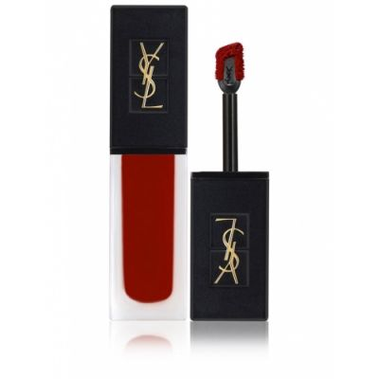

*Always knowing how to impress with luxurious, bold designs, the YSL Tatouage Couture lipstick collection is certainly no exception. YSL cream lipstick put on a proud, splendid shirt typical of the French beauty brand. The luxurious black lip cap is combined with a transparent matte body, lined with gold-plated YSL letters. This is the next step of the Tatouage line and the combined Vinyl cream has created an indelible mark of this matte lipstick version. YSL 216 lipstick is meticulously processed with every detail*